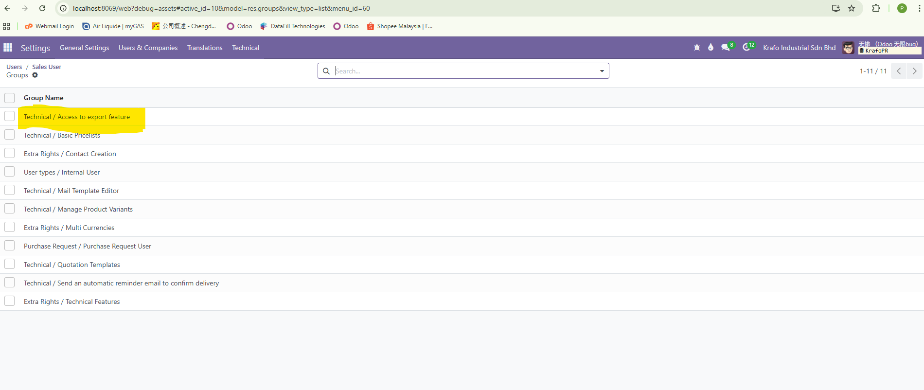  
<http://localhost:8069/web?debug=assets#active_id=10&model=res.groups&view_type=list&menu_id=60> must remove the Group from user if you want hide the export button.  
  
1. if you want hide some menu items for the user , you can go Settings > Technical > User interface > Menu to set up Visibility.  
  
2. if you want hide the download report button ,you must go to Settings > Technical > Actions > Reports. Select the hide menu which you want to set up Visibility.  
  
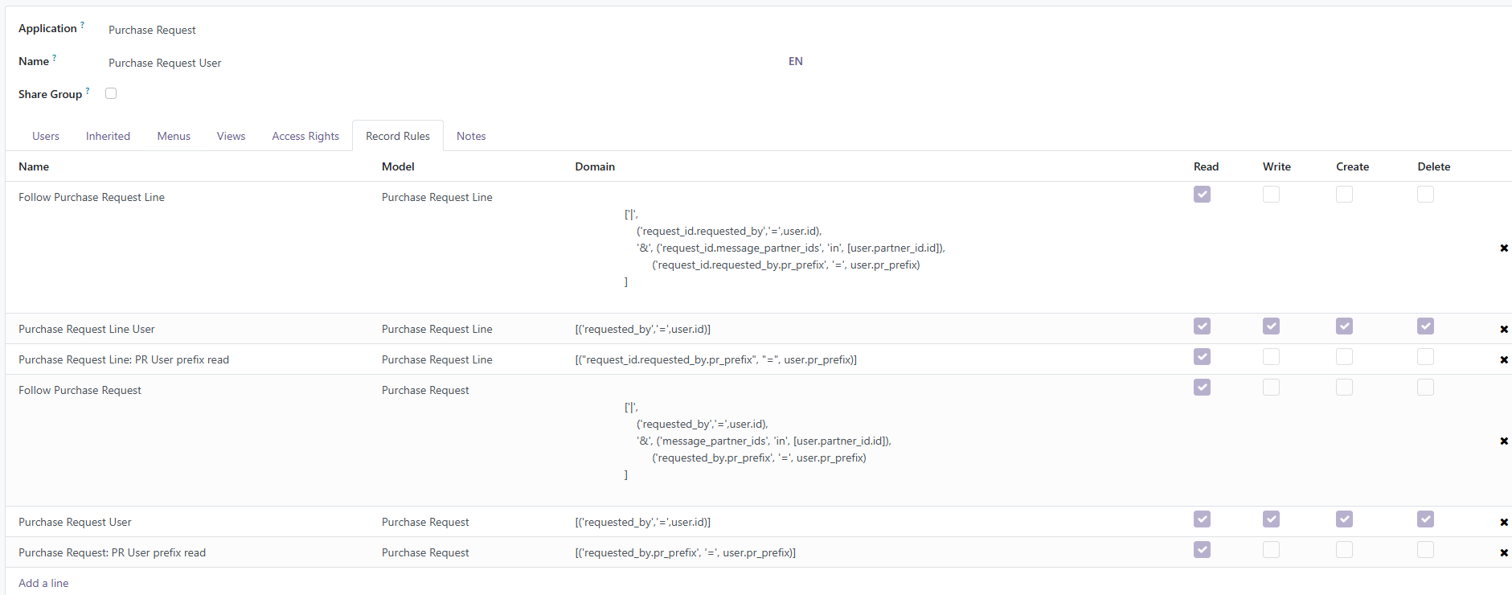

On the Odoo ,you must know how to set up the domain and record rules to prevent user to edit your PR.

At times, we block users from editing the PR through Python code. The PR can only be edited if the Python code itself is modified